S401 Humidity Transducer

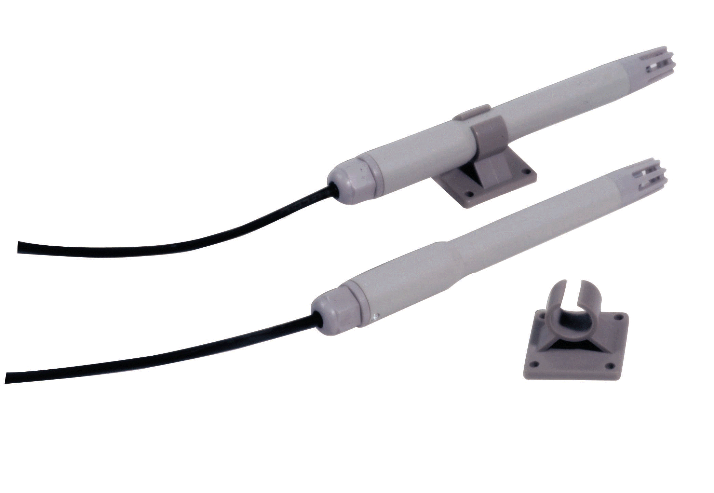
Product Highlights:
Special seal design for anti acid and dust
High anti poor environment ability
Wide operating temperature range
Standard voltage/current output
Special circuit design, wide measurement range
Accurate and stable
This document applies to S401A, S401B, S401C, S401D, S401E, S401F

Applications:

Widely used in food and tobacco processing and storage, large walk in freezer, and industry production sites, as well as any other suitable locations.

Dimensions (mm)

Specification:
 | Humidity
Operating Range | 0%RH ~100%RH
Accuracy | <±2%RH (25 ºC, 10%RH -90%RH)
Long Term Error | <1%RH/year
Sensor | Humidity sensitive capacitor
temperature | -40 ºC ~60 ºC
storage | -40 ºC ~60 ºC
connection | 3 strand (0.2mm²)
Supplied cable length | 1.5m
Housing Material | ABS plastic

Input signal and power supply:
 | S401A | S401B | S401C | S401D | S401E | S401F | Note
Output Signal | 4 mA – 20mA | 0 mA -10mA | 0 mA -20mA | 0 V -10V | 0 V -5V | 0 V -1V
Power Supply | 12 V -24V | 12 V -24V | 12 V -24V | 18 V -24V | 12 V -24V | 5V/7V -24V | DC
Supply Current | <25mA | <15mA | <25mA | <15mA | <15mA | <2mA/15mA
Input Resistance | <500ohm | <500ohm | <500ohm
Load Resistance |  |  |  | >10k | >10k | >10k

Relation between output signal and operating range Relation between Accuracy and operating range

Installation:

Note: pointing the sensor downward will help the accuracy.

Model number
S401 X

Output signal
A: 4-20mA D: 0-10V
B: 0-10mA E: 0-5V
C: 0-20mA F: 0-1V

Connection
S401A: 2 wire current transducer
Yellow

Red

white
Relation between DC supply U and the sampling
resistence Rs: 28V>U>7V+Imax* Rs
Where Imax=20mA
S401B/C: 3 wire current transducer
Yellow

Red

white
Relation between DC supply U and the sampling
resistence Rs: 28V>U>7V+Imax* Rs

红

where Imax=10mA (B type)
or Imax=20mA (C type)

S401D/E/F: Voltage transducer
Yellow

Red

white

RL is the load resistor

U is the DC supply

